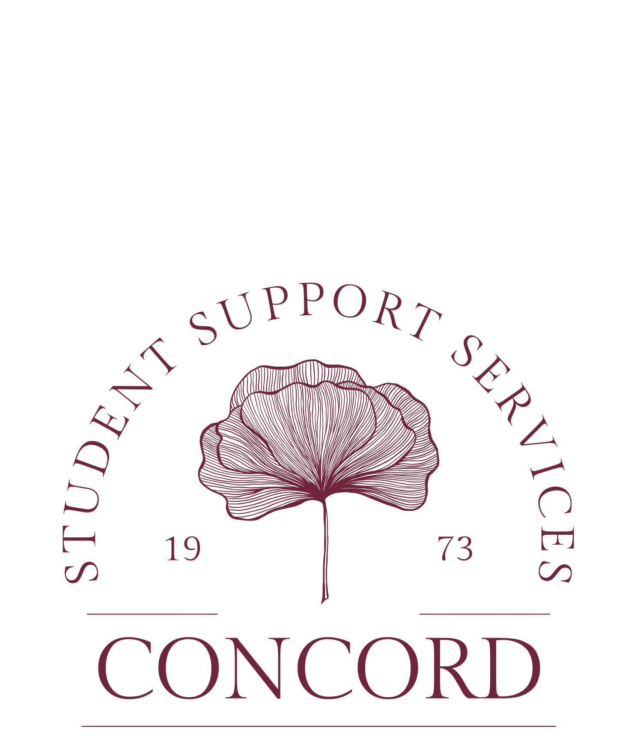

SSS Fall 2026 Calendar
August
18 Classes Begin
21 Welcome Back – 10am-2pm, State Room
25 Organizational Fair-Ballroom-4PM-6PM

September
7 Labor Day-Campus Closed
9 Women’s and Men’s Soccer Game
12 SSS volleyball game
17 SSS Football Game
25 Fall Trip

October
2 Tentatively Parent’s Weekend
3 SSS Football Game
7 Mid-semester grades due
8-9 Fall Break
13 FAFSA Workshop, 10 AM-4PM, State Room
17 Homecoming
19-30 Advising for Course selection
26-30 Course Selection for Spring 2026
30 Halloween Event-10am-2pm
November
12 FAFSA Workshop, 10am-4pm, State Room
18 Fall Career Fair
23-27 Thanksgiving Break

December
2 SSS Fall Open House, State Room, 10am-2PM
FAFSA Workshop, 1872 room, 10am-4PM
4 Last day to drop or withdrawal
7-11 Fall Exams
12 Graduation
15 Final Grades Due

