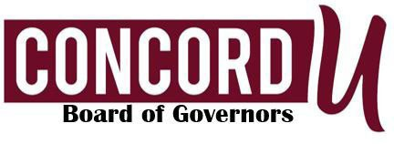
Student Affairs Committee
June 02, 2026, 2 pm
Via Zoom
Committee Members: Sam Baker (Chair), Terri Muscari, Scott Inghram, Brian Strickler

Staff: President Bethany Meighen, Anna Hardy, Luke Duffy, Tesla Southcott, Andrew Sulgit, Lora Woolwine

Committee Areas of Responsibility: Student Affairs, Athletics, and Student Success/Retention

AGENDA

Call to Order and Determination of Quorum
Sam Baker

Approval of Minutes
Sam Baker

Student Affairs Report
Anna Hardy

Athletics Report
Luke Duffy & Tesla Southcott

Student Success/Retention Report
Andrew Sulgit

Other Business
Adjournment

