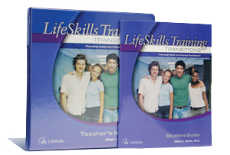

Botvin LifeSkills Training Transitions

Program Overview
The Botvin LifeSkills Training Transitions program is a highly interactive, skills-based curriculum designed to promote positive mental health and personal development. This program helps young adults navigate the transition into the workforce and/or higher education. LST Transitions helps participants achieve competency in the skills that not only are key to success but also have been found to reduce and prevent substance use and violence.

Program Learning Objectives
The LifeSkills Training Transitions program uses a developmentally appropriate, integrated approach designed to strengthen abilities in the following areas:
- Personal Self-Management Skills
Provides participants with strategies for decision-making, managing stress, and managing time and money.
- General Social Skills
Enables participants to strengthen their communication skills and build and maintain relationships in a variety of settings.
- Drug Resistance Skills
Empowers participants to understand the consequences of substance use and risk-taking.

Program Structure
Ages 16+
Consists of 6 sessions
Approximately 40-45 minutes each session
Taught either as on an intensive schedule (two to three times a week) until the program is complete, or on a more extended schedule (once a week for 6 weeks)
Can be used alone or in combination with the LifeSkills Training High School program

If this is something you think could help you or are interested in contact Brandon Whitehouse Collegiate Recovery at: bwhitehouse@concord.edu or call (304) 800-7945 . You can find the WV Collegiate Recovery network on Facebook at https://www.facebook.com/CollegiateRecovers or https://www.facebook.com/CRNWV

