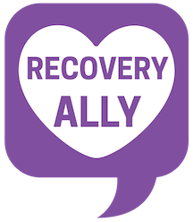

What it means to be a Recovery Ally
The Recovery Ally Training, hosted by the collegiate recovery coach at Concord University, trains faculty, staff, and students to be supportive of individuals struggling with substance use disorders and those in recovery from a substance use disorder. By the end of this training session, attendees will be able to confidently support individuals that are in recovery.
Key points of the training
- Understanding the complex nature of substance use disorder as a disease
- Confronting myths and stigma regarding substance use disorders
- Using empathetic language
- Defining and understanding that recovery is a lifelong journey with multiple pathways
- Knowing available recovery support resources

Most recovery community’s start with the help of recovery ally’s. We need your help to break the stigma and advocate for others in recovery.

Recovery Ally Programs are trainings that are designed to increase a community’s recovery capital, decrease stigma and grow intervention skills. Individual modules include: Basic Science, what does an Ally Do, Racial Justice and Recovery, Philosophies of Care & Pathways to Recovery, Young Adults, Families, Language, and Collegiate Recovery.

For more information on trainings and workshops contact Brandon Whitehouse at : bwhitehouse@concord.edu or call 304-800-7945
You can find the WV Collegiate Recovery Network on Facebook at https://www.facebook.com/CollegiateRecovers
https://www.facebook.com/CRNWV

