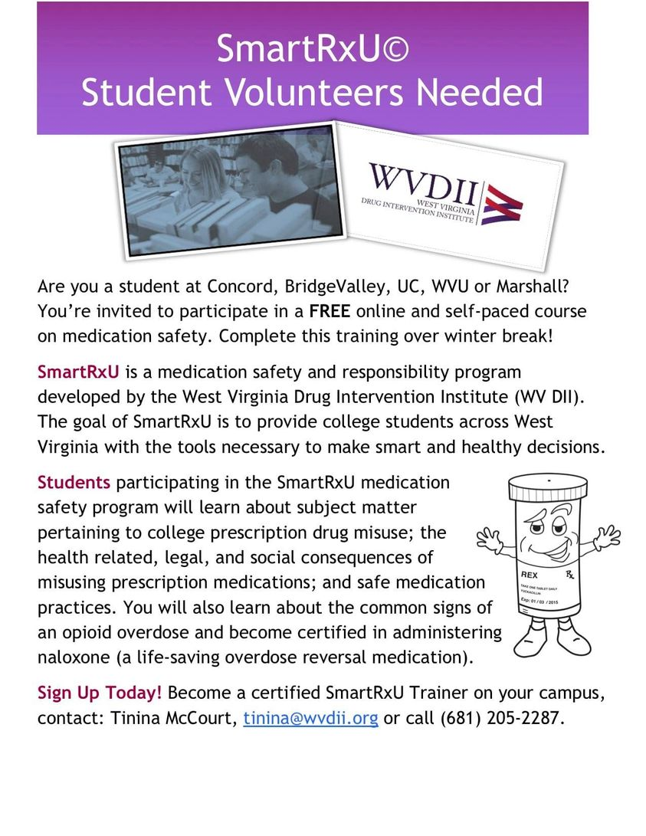

The Concord Collegiate Recovery Coach can facilitate these trainings as well. Contact Brandon Whitehouse at [bwhitehouse@concord.edu](mailto:bwhitehouse@concord.edu) or call 304-800-7945